CHANDIGARH UNIVERSITY
SCAM SLEUTH
INTELLIGENT FAKE JOB AND INTERNSHIP
DETECTION USING DATA MINING

A Data Mining Mini Project Report submitted in partial fulfilment of the academic requirements of the Bachelor of Computer Applications (BCA) programme.
Submitted by: Gurnoor Kaur
UID / Roll No.: 24BCA10533
Class: 6A
Department / Programme: Bachelor of Computer Applications
Institution: Chandigarh University
Academic Session: 2026–2027
Project status: Academic data-mining prototype evaluated on the supplied public job-postings dataset. Model predictions are screening signals only and are not proof of fraud.

CERTIFICATE, DECLARATION AND ACKNOWLEDGEMENT

Certificate
This is to certify that the mini project report entitled “SCAM SLEUTH – Intelligent Fake Job and Internship Detection Using Data Mining” has been prepared by Gurnoor Kaur (UID 24BCA10533), Class 6A, as an academic project for the Bachelor of Computer Applications programme at Chandigarh University. The work presents the problem definition, data preparation plan, data mining methodology, proposed system architecture and evaluation framework for identifying potentially fraudulent job advertisements.
The report is submitted for academic evaluation. The project is an educational prototype and does not represent an officially deployed recruitment-verification service. The name, signature and date of the project guide / evaluator may be entered by the department.

Student Declaration
I declare that this report has been prepared for academic purposes. Sources used for the dataset, concepts and software tools are acknowledged in the references. Any model output described in this report is to be generated by executing the accompanying implementation on the selected dataset. No unrun experiment, accuracy score or real-world deployment claim is presented as a verified result.

Acknowledgement
I express my sincere gratitude to the faculty members of Chandigarh University and the Department of Computer Applications for the academic guidance and learning environment that support this mini project. I also acknowledge the authors and maintainers of open educational resources, Python libraries and publicly available research datasets that make practical data mining exercises possible. Finally, I thank my classmates and family for their encouragement during the planning and documentation of this project.

ABSTRACT AND KEYWORDS

Abstract
Online recruitment makes internships and entry-level jobs easier to discover, but it also gives misleading advertisers a way to reach applicants. A job posting may look professional while hiding warning signs such as vague employer details, unrealistic benefits, missing company information or requests for money. Students who are new to the job market may find it difficult to distinguish an unusual but genuine vacancy from a potentially fraudulent one.
SCAM SLEUTH is a proposed data mining mini project that analyses job-posting records to identify patterns associated with potentially fraudulent advertisements. It combines text processing with structured data analysis. The workflow includes dataset inspection, missing-value treatment, text normalisation, feature engineering, classification, clustering and association-rule exploration. A classification model can estimate a risk category when labelled examples are available. Clustering can group postings with similar characteristics, while association rules can reveal combinations of features that frequently occur together.
The intended output is an interpretable academic prototype: a posting-level prediction, selected warning indicators and visual summaries of the dataset. The system is designed as a screening aid rather than a final authority. A model may make mistakes, may reflect biases in its training data and cannot establish whether a real employer is genuine. Users should independently verify company websites, official contact details and recruitment procedures.
The analysis was carried out in Python using pandas, scikit-learn and Matplotlib. The supplied CSV was inspected, cleaned for analysis and used to generate the charts and classification results presented later in this report. Google Colab is a suitable environment for reproducing the workflow. The report distinguishes measured results from design recommendations and does not treat a model prediction as a final judgement about an employer.
Keywords: Data Mining; Recruitment Fraud; Fake Job Posting; Text Mining; Classification; Clustering; Association Rules; TF-IDF; Python; Google Colab.

INTRODUCTION AND BACKGROUND

1.1 Introduction
Recruitment platforms connect employers and applicants through searchable job advertisements. A single advertisement may contain a title, company profile, location, employment type, salary range, experience requirements, benefits and a long description. These fields provide useful information, but they can also be incomplete, inconsistent or deliberately misleading. Students who are searching for their first internship may have limited experience in judging whether an offer is credible.
Data mining is the process of discovering useful patterns and relationships in large collections of data. It can support recruitment-safety analysis by examining recurring characteristics across many advertisements rather than relying on one isolated phrase. For example, an advertisement may combine an unusually attractive salary claim with an incomplete company profile and a request for an upfront fee. A data mining system can learn whether combinations like these are associated with labelled fraudulent examples in a historical dataset.

1.2 Why the Problem Matters
A suspicious job advertisement can cause financial loss, identity exposure, wasted time and emotional stress. Applicants may be asked to pay for registration, training, equipment, background checks or interview access. Others may be directed to unofficial messaging accounts or forms that request sensitive documents. These patterns do not prove fraud in every case, but they are reasonable signals for additional verification.
A student-focused tool is useful because it can translate technical analysis into understandable warnings. Rather than displaying only a label, SCAM SLEUTH aims to show which data fields contributed to the alert, such as missing company details, suspicious wording or unusual compensation information. The explanation helps users ask better questions and verify the employer through independent channels.

1.3 Data Mining Perspective
The project is not merely a keyword filter. Keyword filters can flag legitimate postings that use common recruitment language and miss scams that avoid obvious terms. A data mining approach evaluates multiple features, learns from examples and explores relationships among variables. Combining text and structured attributes can provide a richer representation of each posting.

PROBLEM STATEMENT, NEED AND MOTIVATION

2.1 Problem Statement
The problem addressed by SCAM SLEUTH is the difficulty of consistently screening large volumes of online job and internship advertisements for patterns associated with recruitment fraud. Applicants often have to inspect each posting manually. Important warning signals may be hidden in long descriptions, missing fields, unrealistic claims or combinations of otherwise ordinary attributes. The proposed system uses data mining methods to organise these signals and estimate whether a posting resembles fraudulent examples in a labelled dataset.

2.2 Existing Challenges
First, job descriptions are unstructured text. Similar meanings can be expressed using different words, spelling variations and sentence structures. Second, datasets may contain missing company profiles, salary information or location details. Third, fraudulent examples are often less common than legitimate examples, creating class imbalance. Fourth, a model trained on one platform or time period may not generalise to another platform. Fifth, a prediction can be misunderstood as a guarantee unless uncertainty is communicated clearly.

2.3 Motivation
The project is motivated by the need for a practical student-facing demonstration of how data mining can support safer digital decisions. It brings together several concepts taught in a BCA data mining course: preprocessing, feature extraction, supervised learning, unsupervised learning, association analysis and visualisation. It also demonstrates the importance of responsible interpretation: data quality, evaluation design and human verification matter as much as the algorithm.

2.4 Proposed Solution
SCAM SLEUTH accepts a dataset of job advertisements, prepares the records, extracts useful features and applies selected mining techniques. For a new posting, the trained classification pipeline can return a predicted category and a probability-like confidence score when supported by the model. A separate explanation layer lists observable warning indicators. Dataset-level charts show class distribution, missingness, frequent terms and patterns discovered by mining methods.
Important boundary: SCAM SLEUTH identifies patterns in data. It does not verify company registration, investigate an employer, contact recruiters or prove criminal activity.

OBJECTIVES, SCOPE AND EXPECTED OUTCOMES

3.1 Main Objective
To design and implement an educational data mining prototype that analyses job-posting text and structured attributes to flag advertisements that resemble fraudulent examples in a labelled dataset, while presenting understandable evidence and limitations.

3.2 Specific Objectives
- Collect or load a documented public job-posting dataset containing labelled examples, subject to its licence and usage conditions.
- Inspect the dataset schema, class distribution, duplicate records, missing values and inconsistent categories.
- Clean text fields through lowercasing, whitespace normalisation and removal of irrelevant noise without destroying meaningful warning phrases.
- Create text features using TF-IDF and structured features from fields such as company profile, employment type, salary and location.
- Train and compare suitable classification models using a leakage-aware train/test split and appropriate metrics.
- Apply clustering to explore groups of similar advertisements without treating clusters as verified fraud categories.
- Use association-rule mining on selected binary indicators to discover recurring feature combinations.
- Prepare visualisations and an interpretable output format for academic demonstration.

3.3 Scope
The mini project focuses on offline analysis of a public dataset and demonstration through Google Colab. It does not scrape websites, collect applicant data, connect to recruitment platforms or automatically block advertisements. The prototype can analyse a supplied record if its fields are mapped to the training schema. The scope is limited to the attributes available in the selected dataset.

3.4 Expected Outcomes
Expected deliverables include a reproducible notebook, a cleaned dataset workflow, model evaluation tables generated during execution, clustering and association-analysis outputs, explanatory charts and this report. The project should demonstrate a complete data mining lifecycle rather than claim a production-ready fraud detector.

LITERATURE REVIEW AND CONCEPTUAL FOUNDATION

4.1 Recruitment Fraud as a Data Problem
Recruitment-fraud research commonly treats job advertisements as records that can be represented through textual and non-textual attributes. Textual attributes include the job title, description, requirements and benefits. Structured attributes include telecommuting status, employment type, required experience, company profile availability and salary-range fields. A combined representation allows models to examine both the language and the context of an advertisement.

4.2 Supervised Learning
Supervised learning uses examples with known labels. In this project, the target label indicates whether a posting is marked fraudulent or legitimate in the source dataset. A model learns statistical relationships between input features and the target. Logistic Regression provides a useful baseline, while tree-based models can represent non-linear relationships. The best model should be selected using held-out evaluation rather than training accuracy alone.

4.3 Text Mining
Text mining converts written descriptions into a numerical representation. A bag-of-words representation counts terms, while TF-IDF reduces the influence of terms that appear in almost every document and increases the relative importance of terms that are more distinctive. N-grams can capture short phrases such as “pay fee” or “work from home”. Text features are useful but should not be interpreted as definitive evidence.

4.4 Unsupervised and Association Methods
Clustering groups records by similarity without using the target label during cluster formation. It can reveal groups with similar descriptions or metadata, but a cluster is not automatically a fraud category. Association-rule mining identifies co-occurrence patterns among binary attributes. Support measures how often an itemset appears, confidence measures conditional frequency and lift compares the observed co-occurrence with what would be expected under independence.

4.5 Research Gap for This Mini Project
A classroom demonstration can become misleading if it reports only a single accuracy score. This project therefore includes class balance, precision, recall, F1-score, confusion matrix, error inspection and model limitations. It also combines classification with exploratory clustering and association rules to demonstrate a broader range of data mining concepts.

EXISTING SYSTEM AND PROPOSED SYSTEM

5.1 Existing Manual Approach
In a manual approach, an applicant reads the advertisement, searches for the company, checks contact details and decides whether to proceed. This approach can be effective when the applicant has enough time and experience, but it is difficult to apply consistently across hundreds of postings. Different people may interpret the same warning sign differently.

5.2 Simple Keyword Filtering
A basic automated filter may search for terms such as “registration fee”, “guaranteed income” or “urgent hiring”. It is easy to build and explain, but it can produce false alarms. Legitimate advertisements may contain these words in a warning or policy context, while deceptive advertisements may use indirect language. Keyword filtering also ignores combinations among company profile, salary and employment attributes.

5.3 Proposed SCAM SLEUTH System
The proposed system uses a repeatable pipeline. It loads a documented dataset, validates the columns, prepares text and structured features, trains classification models and produces evaluation metrics. Additional modules perform clustering and association-rule mining. The final presentation includes a risk-oriented label, selected signals and a reminder that the output requires human verification.

5.4 Comparative Summary
Aspect | Manual review | Keyword filter | SCAM SLEUTH prototype
Consistency | Depends on reviewer | Rule-dependent | Repeatable pipeline
Text analysis | Human reading | Exact term matching | TF-IDF / n-grams
Structured fields | Manual inspection | Usually limited | Combined features
Pattern discovery | Limited at scale | No | Clustering + rules
Evaluation | Subjective | Often absent | Held-out metrics
Decision | Human | Rule alert | Model signal + human review

The proposed system does not replace manual verification. It organises information and prioritises records for further inspection. A careful human review remains necessary, particularly when the consequences of a false accusation or missed warning are significant.

DATASET DESCRIPTION AND DATA DICTIONARY

6.1 Dataset Selection
A suitable starting point is the publicly available Employment Scam Aegean Dataset (often referred to as the fake job postings dataset), which has been used in educational and research demonstrations of recruitment-fraud classification. Before use, the student must download the dataset from its original host, read the current licence and dataset documentation, and record the exact version and access date in the notebook. Dataset availability, column names and licence terms should be checked at the time of use.
The commonly circulated dataset contains job-posting fields such as title, location, department, salary range, company profile, description, requirements, benefits, telecommuting, company logo, questions and a fraud label. The exact schema should be confirmed from the downloaded file rather than assumed. The target column is commonly named fraudulent, but the notebook should inspect the actual column names.

6.2 Data Dictionary (Typical Fields)
Field | Meaning | Possible use
title | Role title | Text feature
location | Advertised location | Categorical / text
department | Department name | Categorical
salary_range | Advertised pay range | Numeric/text parsing
company_profile | Employer profile text | Text + missingness
description | Main job description | TF-IDF text
requirements | Required skills / experience | TF-IDF text
benefits | Listed benefits | Text / missingness
telecommuting | Remote-work indicator | Binary
has_company_logo | Logo indicator | Binary
has_questions | Application questions indicator | Binary
fraudulent | Dataset target label | Classification target

6.3 Data Quality Considerations
Some fields may be blank because the employer did not provide the information, because the platform did not collect it, or because the dataset export omitted it. Missingness should be measured before filling values. For text fields, a neutral empty string can be used in a text pipeline, while structured categorical fields may use an explicit “Unknown” category. Missing values should not automatically be treated as evidence of fraud.
The dataset may contain class imbalance. The number and percentage of fraudulent and legitimate examples must be calculated before modelling. Duplicate advertisements should be checked because duplicate or near-duplicate records can leak across training and testing if the split is not designed carefully.

DATA PREPROCESSING AND FEATURE ENGINEERING

7.1 Data Inspection
The first stage loads the CSV file into a pandas DataFrame and inspects its shape, column names, data types, sample rows and missing-value counts. The target variable is checked for valid values. Duplicate rows are identified, and the distribution of labels is examined. This initial inspection prevents later steps from silently operating on incorrect assumptions.

7.2 Text Cleaning
Text fields are combined only after checking their availability. A safe cleaning function converts null values to empty strings, converts text to lowercase, normalises repeated whitespace and preserves meaningful words. Punctuation may be removed for a baseline model, but experiments with n-grams should retain useful phrase boundaries. Stop-word removal is optional: words that appear common in language can still matter in a specific recruitment context.

7.3 Structured Feature Preparation
Binary columns such as telecommuting and has_company_logo should be converted into consistent numeric or categorical values. Salary range requires special care because it may be stored as text, may include currencies and may represent a range rather than a single amount. If salary is parsed, the transformation should document assumptions and preserve an indicator for values that could not be parsed.

7.4 Feature Engineering
Text features can be created from the title, company profile, description, requirements and benefits. Structured features can include location, department, employment type and binary indicators. Derived features may include description length, number of missing profile fields, presence of external links and counts of carefully selected phrases. Such features should be justified and inspected for leakage.
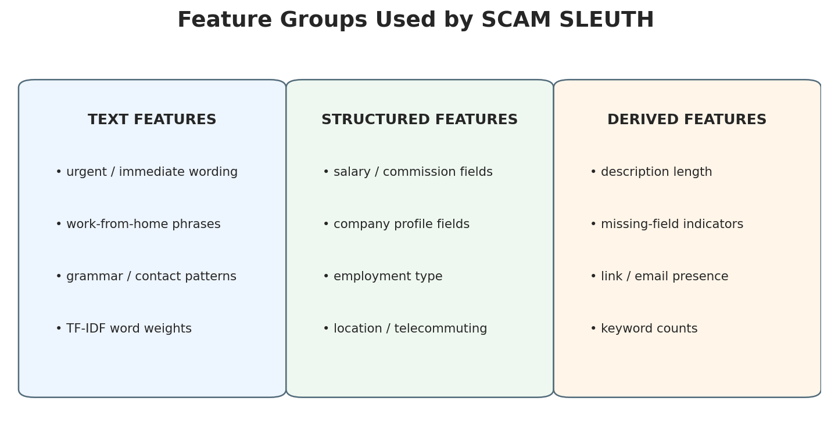
Feature groups used in the SCAM SLEUTH pipeline.

7.5 Preventing Data Leakage
All transformations that learn from data, including vocabulary construction, scaling and imputation statistics, must be fitted only on the training portion. A scikit-learn Pipeline or ColumnTransformer helps enforce this rule. The test set must remain unseen until final evaluation. If duplicate or near-duplicate postings exist, group-aware splitting may be preferable to a random row split.

METHODOLOGY AND SYSTEM ARCHITECTURE

8.1 Methodology
The project follows a staged knowledge-discovery workflow: understand the problem, select data, inspect and preprocess records, transform fields into features, apply mining algorithms, evaluate the outputs and communicate findings. Each stage produces an artefact that can be checked and reproduced.
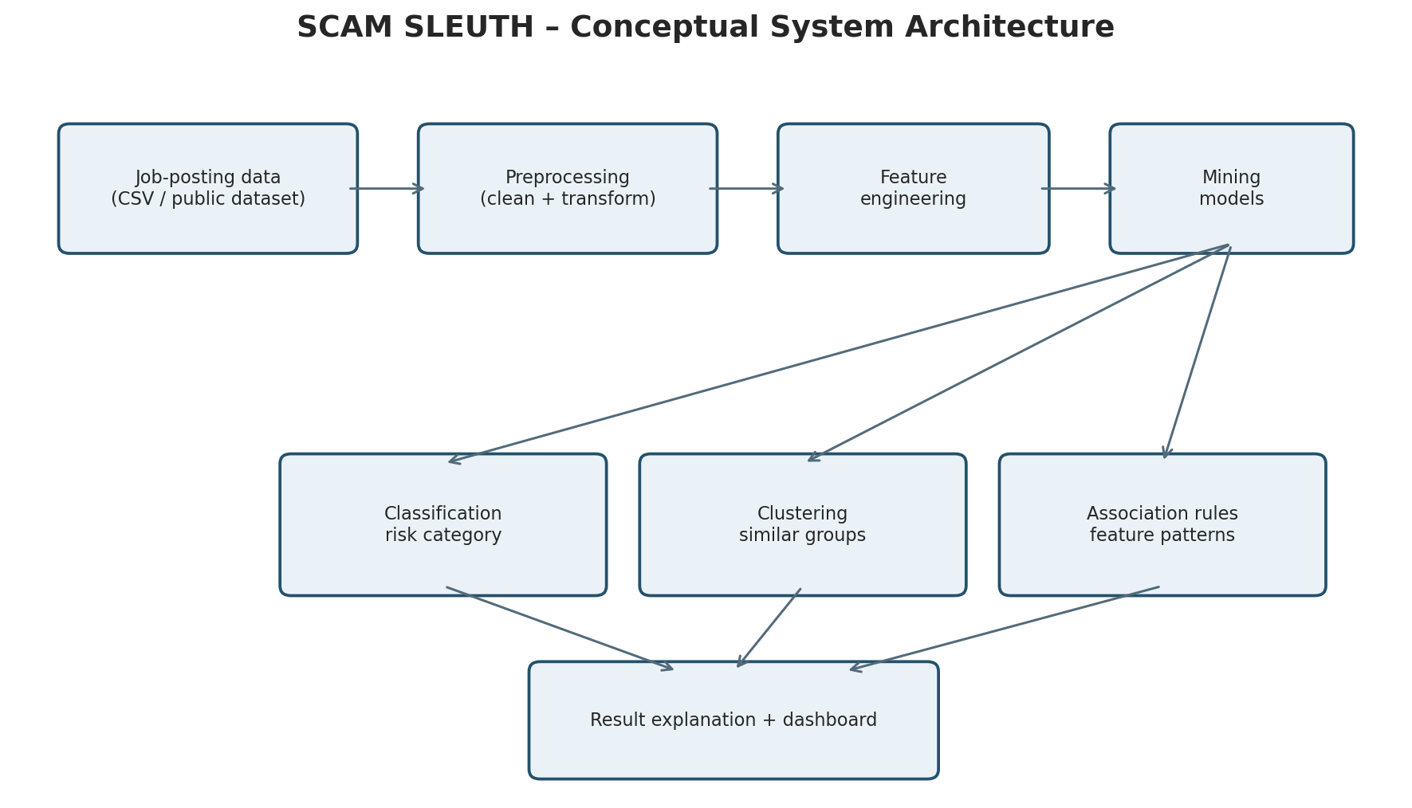
Conceptual architecture of the proposed SCAM SLEUTH system.

8.2 Architecture Components
- Data input layer: reads the public CSV file and validates expected columns.
- Preprocessing layer: handles null values, duplicates, data types and text normalisation.
- Feature layer: transforms text through TF-IDF and encodes structured attributes.
- Mining layer: trains classification models, explores clusters and generates association rules.
- Evaluation layer: calculates metrics and displays confusion matrices and error examples.
- Presentation layer: summarises model output and warning signals in charts or a simple interface.

8.3 Data Flow
A record enters the system as a job advertisement. Its text fields are normalised and combined according to a documented feature strategy. Structured fields are encoded separately. The resulting feature matrix is passed to the trained classifier. The output is shown alongside selected input indicators and a caution message. Dataset-level mining modules operate on the prepared data to discover broader patterns.

8.4 Architecture Boundary
The architecture is designed for a local academic notebook. It does not contain a live crawler, user account system, cloud database, employer verification API or automated enforcement mechanism. These features would require additional security, legal and operational design.

CLASSIFICATION: SUPERVISED DATA MINING

9.1 Classification Concept
Classification assigns an observation to one of a set of predefined classes. In SCAM SLEUTH, the target is the dataset label for fraudulent versus legitimate job postings. The classifier learns from labelled historical examples and estimates the class of an unseen record. Its predictions are only as reliable as the representativeness and quality of the training data.

9.2 Baseline: Logistic Regression
Logistic Regression is a useful baseline for binary classification. It estimates the probability of a class using a weighted combination of input features and a logistic function. It is efficient for sparse TF-IDF matrices and can provide interpretable feature coefficients, although correlated features and high-dimensional text can complicate interpretation.

9.3 Alternative: Random Forest
Random Forest combines predictions from multiple decision trees trained on bootstrapped samples and feature subsets. It can model non-linear interactions in structured features and is relatively robust to some forms of noise. However, it may be computationally heavier and may not directly exploit sparse text representations as efficiently as linear models. A practical comparison can use a reduced text representation or a combined sparse feature pipeline.

9.4 Training and Testing
The dataset is divided into training and test subsets using a fixed random seed and stratification where appropriate. Stratification aims to preserve class proportions in both subsets. The vectoriser and encoders are fitted on training data only. Model selection may use cross-validation within the training set; the test set is reserved for the final comparison.

9.5 Classification Output
The prototype can display “model flags as potentially fraudulent” or “model does not flag as potentially fraudulent”. These labels are deliberately cautious. A positive prediction should trigger verification, not an accusation. A negative prediction should not be interpreted as a guarantee that the advertisement is safe.

CLUSTERING AND ASSOCIATION RULE MINING

10.1 Clustering
Clustering is an unsupervised technique that groups observations based on similarity. K-Means is a common algorithm that assigns records to a selected number of clusters by minimising within-cluster squared distances. In this project, clustering can be applied to a reduced numerical feature space or to TF-IDF vectors after dimensionality reduction. The number of clusters should be explored rather than chosen to force a desired fraud grouping.

10.2 Interpreting Clusters
Cluster profiles can be summarised by frequent terms, average description length, missingness and structured-field proportions. A cluster may represent remote roles, sales roles, incomplete postings or a mixture of patterns. A cluster should not be named “fraud” merely because it contains some fraudulent labels. The labels can be examined after clustering for exploratory interpretation, not used to train the unsupervised grouping.

10.3 Association Rule Mining
Association rules discover item combinations that occur together. For example, a rule may examine whether missing company profile and a particular application pattern co-occur in the dataset. The Apriori algorithm identifies frequent itemsets above a minimum support threshold and derives rules using confidence and lift. The chosen binary indicators must be meaningful and the thresholds must be reported.

10.4 Key Measures
Support(A) = count(A) / total number of records
Confidence(A → B) = Support(A ∪ B) / Support(A)
Lift(A → B) = Confidence(A → B) / Support(B)
Lift greater than 1 indicates that B occurs more often with A than would be expected if A and B were independent in the dataset. It does not establish causation. Low support can make a rule unstable, while very high confidence can arise from a common consequent. Both support and lift should be reviewed.

10.5 Combined Value
Classification provides a prediction for an individual record; clustering provides an overview of similarity groups; association rules highlight co-occurring indicators. Their outputs answer different questions and should be presented as complementary analyses rather than merged into one unvalidated score.

IMPLEMENTATION PLAN AND GOOGLE COLAB ENVIRONMENT

11.1 Tools and Libraries
Tool / Library | Role in project
Google Colab | Cloud notebook execution environment
Python | Programming language
pandas | Data loading and tabular manipulation
NumPy | Numerical operations
scikit-learn | Preprocessing, classification and evaluation
Matplotlib / Seaborn | Charts and visual analysis
mlxtend (optional) | Apriori and association rules

11.2 Notebook Structure
The analysis workflow is organised into clear stages: importing libraries, loading the CSV, checking the schema, reviewing missing values, preparing text fields, building TF-IDF features, splitting the data, training the baseline classifier, evaluating its predictions, exploring clusters and examining association rules. Keeping these stages separate makes it easier to locate an error and explain each step during a practical demonstration.

11.3 Reproducibility
For reproducibility, the classification experiment uses a fixed random seed of 42 and a stratified 80:20 train-test split. The supplied file is named DataSet.csv. The same file and split settings should be used when repeating the experiment. Minor differences can occur if library versions or preprocessing steps change, so the dataset version and software environment should be recorded with any future rerun.

11.4 Suggested Execution Sequence
- Open Google Colab and create a notebook named SCAM_SLEUTH_Data_Mining.ipynb.
- Upload DataSet.csv through the Colab file panel or the notebook upload control.
- Run the inspection cells and confirm that the target column is fraudulent and that the class labels are interpreted correctly.
- Run text preparation, TF-IDF feature extraction, the stratified split and Logistic Regression training in sequence.
- Generate the class-distribution chart, missing-value chart, phrase-frequency chart, confusion matrix and metric summary.
- Run the clustering and association-rule exploration cells, then save the figures and note the software versions used.
The report describes the implementation plan. Actual screenshots and numerical results should be captured from the executed notebook rather than fabricated.

EVALUATION FRAMEWORK AND PERFORMANCE MEASURES

12.1 Why Accuracy Is Not Enough
Accuracy is the fraction of all predictions that are correct. If legitimate postings greatly outnumber fraudulent postings, a model that predicts every record as legitimate can appear accurate while failing to identify the minority class. Therefore, the project must report class-wise precision, recall and F1-score, together with the confusion matrix.

12.2 Evaluation Metrics
Metric | Meaning | Project interpretation
Accuracy | Correct predictions / all predictions | Overall correctness; can mislead with imbalance
Precision | TP / (TP + FP) | How many flagged records are actually labelled fraud
Recall | TP / (TP + FN) | How many labelled fraudulent records are detected
F1-score | Harmonic mean of precision and recall | Balances precision and recall
Confusion matrix | Counts TP, TN, FP and FN | Shows types of mistakes

12.3 Error Types
A false positive occurs when a legitimate posting is flagged. This may cause an applicant to avoid a genuine opportunity or unfairly distrust an employer. A false negative occurs when a fraudulent posting is not flagged. This may expose an applicant to risk. The preferred balance depends on the use case; a student safety tool should communicate uncertainty and encourage verification for all postings.

12.4 Evaluation Procedure
The experiment uses a stratified hold-out test set so that the minority class is represented in both training and testing data. The confusion matrix is reviewed alongside precision, recall and F1-score. In a further study, repeated cross-validation and an independent dataset would provide a stronger estimate of how well the model generalises beyond this particular file.

The measured Logistic Regression results from the supplied dataset are summarised in the experimental-results section. The current experiment does not include a measured Random Forest comparison; that model is listed only as a possible extension and is not presented as a completed result.
Model | Accuracy | Precision (fraud) | Recall (fraud) | F1 (fraud)
Logistic Regression (measured) | 98.38% | 78.61% | 91.33% | 84.49%
Random Forest | Not evaluated | Not evaluated | Not evaluated | Not evaluated

Only the Logistic Regression model has been evaluated in this report. A Random Forest comparison is suggested as future work; no result is claimed for it.

VISUALISATION, DASHBOARD AND OUTPUT DESIGN

13.1 Purpose of Visualisation
Visualisation helps communicate patterns that are difficult to understand from raw tables. The project should include a class distribution chart, missing-value chart, frequent-term chart, confusion matrix heatmap and cluster profile visualisation. Each chart needs a title, axis labels, legend where needed and a short interpretation.

13.2 Suggested Dashboard Sections
- Dataset overview: total records, number of labelled classes and missing-value summary.
- Text insights: frequent terms and TF-IDF features with a note that frequency is not proof of fraud.
- Model evaluation: precision, recall, F1-score and confusion matrix.
- Pattern discovery: cluster summaries and selected association rules.
- Single-post screening: input fields, model output, warning indicators and verification reminder.

13.3 User Output Example
A demonstration output may show a fictional job title, the model's predicted category and a short list of observed signals. The interface should clearly state that the prediction is generated from a historical dataset and does not authenticate the employer. Any fictional sample must be labelled as illustrative and must not be presented as a real case.

13.4 Design Principles
Use clear labels such as “Needs further verification” rather than “Scam confirmed”. Avoid alarming colours as the only way to communicate risk; pair colour with text. Do not display unnecessary personal information. Provide a brief explanation of why the model produced its result and make it easy to see the limitations.

SECURITY, PRIVACY, ETHICS AND RESPONSIBLE USE

14.1 Privacy
The prototype should use public, appropriately licensed job-posting data and should not collect applicant names, phone numbers, identity documents, bank details or private messages. If a user tests a posting, the system should avoid storing personal contact information. Any future web application would need a privacy notice, access controls, secure storage and a defined retention policy.

14.2 Fairness and Bias
The source dataset may reflect the platform, geography, language and period in which it was collected. A model may incorrectly flag legitimate small businesses, remote jobs, commission-based roles or postings from underrepresented regions. Evaluation should inspect errors across relevant groups where reliable data exists. Sensitive personal characteristics should not be used as predictive features.

14.3 Explainability
Users should be shown understandable signals such as missing employer details or suspicious wording, but explanations must not imply certainty. Feature importance or model coefficients describe associations learned from the dataset, not the actual intent of an employer. A clear disclaimer should accompany every output.

14.4 Responsible Action
The system should never automatically publish accusations, blacklist a company or contact an employer. Users should independently verify the employer through its official website, known corporate contact details and recognised recruitment channels. Applicants should be cautious about upfront payments and requests for sensitive information, and should consult trusted adults or institutional placement staff when unsure.

14.5 Limitations
A model trained on historical records may become outdated as scam tactics change. Dataset labels may contain errors. Text can be deliberately manipulated. Missing fields may reflect platform design rather than deception. A model's probability score may be poorly calibrated. These limitations require periodic evaluation and careful wording.

TESTING, VALIDATION AND QUALITY ASSURANCE

15.1 Testing Objectives
Testing checks whether the notebook runs in the correct order, whether the preprocessing pipeline handles expected data conditions, whether the model produces valid outputs and whether the evaluation code calculates metrics correctly. Testing should cover both normal records and edge cases.

15.2 Test Cases
Test ID | Test scenario | Expected behaviour
T01 | CSV file uploaded successfully | Dataset loads and shape is displayed
T02 | Optional text field is blank | Pipeline handles missing text safely
T03 | Duplicate rows present | Duplicates are identified and policy is applied
T04 | Target contains unexpected value | Validation reports invalid label
T05 | Model training completes | Fitted model is available for prediction
T06 | Test data is evaluated | Metrics and confusion matrix are produced
T07 | New posting has missing fields | Input validation gives clear message or safe defaults
T08 | Association rules have no qualifying itemsets | Notebook reports no rules rather than failing

15.3 Validation Strategy
Validation includes checking dataset assumptions, confirming the target mapping, reviewing class distribution and verifying that preprocessing is fitted only on training data. The notebook should be rerun from a clean runtime to ensure it does not depend on hidden variables from earlier cells. Charts and result tables should be checked against the underlying counts.

15.4 Quality Criteria
A successful academic implementation should be reproducible, clearly documented, free from avoidable data leakage, appropriately evaluated and transparent about limitations. The report should match the notebook outputs. If a result changes after a dataset update or code correction, the report must be regenerated rather than retaining stale figures.

PROJECT PLANNING, FEASIBILITY AND RESOURCE REQUIREMENTS

16.1 Technical Feasibility
The project is technically feasible as a student-level notebook because its core operations are supported by commonly used Python libraries and Google Colab. A moderate public dataset can be explored without setting up a local development environment. Text vectorisation and tree-based methods may require runtime and memory awareness, so the student should begin with a baseline model and add complexity only when needed.

16.2 Economic Feasibility
The academic prototype can be developed using free or open-source software and a publicly accessible dataset, subject to the dataset's licence. No paid cloud deployment is required for the demonstration. Optional hosting, monitoring or external verification services would introduce additional costs and are outside the current scope.

16.3 Operational Feasibility
The notebook workflow is suitable for a student demonstration because it can be executed in a browser and explained cell by cell. The output is designed for applicants and placement-support staff as an educational screening aid. A production tool would need user testing, accessibility work, support procedures and clear accountability.

16.4 Indicative Work Plan
Phase | Activity | Deliverable
1 | Problem definition and dataset review | Scope and data source note
2 | Data inspection and cleaning | Prepared dataset workflow
3 | Feature engineering | Text and structured feature pipeline
4 | Classification experiments | Model and evaluation output
5 | Clustering and association analysis | Exploratory pattern results
6 | Visualisation and validation | Charts and test evidence
7 | Documentation and presentation | Final report and demonstration

16.5 Risks and Mitigation
Potential risks include dataset access changes, incompatible column names, missing values, class imbalance, long runtime and misleading interpretation. Mitigation includes checking the schema first, documenting the data version, using robust preprocessing, comparing appropriate metrics, keeping a simple baseline and displaying limitations beside every prediction.

FUTURE ENHANCEMENTS AND CONCLUSION

17.1 Future Enhancements
A future version could provide a simple web interface where a user pastes a job description and receives a cautious screening result. This would require secure input handling and a clear privacy policy. Additional improvements could include time-based evaluation, periodic retraining with verified labels, multilingual text support, calibration of confidence scores and explainability tools. An official employer verification source could be integrated only where lawful access and reliable APIs are available.
A further extension could compare models across different recruitment platforms and job categories. This would help identify whether the model performs consistently or whether it requires domain-specific calibration. Human feedback could be collected in a privacy-preserving manner, but user reports should not automatically become ground-truth labels without verification.

17.2 Conclusion
SCAM SLEUTH demonstrates how data mining can be applied to a practical problem affecting students and job seekers. By combining text mining, structured feature engineering, classification, clustering and association-rule analysis, the project provides a systematic way to explore patterns associated with fraudulent job advertisements. It also highlights the importance of careful preprocessing, leakage prevention, class-imbalance awareness and suitable evaluation metrics.
The main value of the project is not a promise that software can identify every scam. Its value is the structured analysis of available evidence and the communication of uncertainty. A responsible system supports human judgement, encourages independent verification and avoids presenting a model prediction as a final legal or factual conclusion.
The project meets its academic purpose when the notebook is executed on a documented dataset, the actual outputs are inserted into the results section and the limitations are explained during demonstration. This makes SCAM SLEUTH a practical example of the data mining lifecycle and responsible machine learning.

ACTUAL EXPERIMENTAL RESULTS AND DATA VISUALISATIONS
The following figures and measurements were generated by running the analysis on the CSV file supplied for this report. The dataset contains 17,880 job postings and 18 fields. The target field is fraudulent; the values f and t represent legitimate and potentially fraudulent postings respectively.
There are 17,014 legitimate postings (95.16%) and 866 potentially fraudulent postings (4.84%). This imbalance is important when evaluating a classifier: a high overall accuracy can hide weak performance on the smaller class. The additional in_balanced_dataset field was not used as the prediction target.
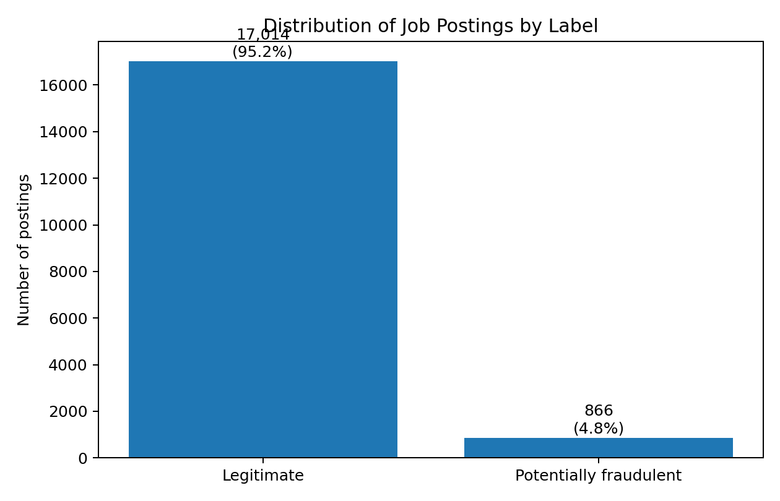
Figure 1. Class distribution in the supplied dataset.
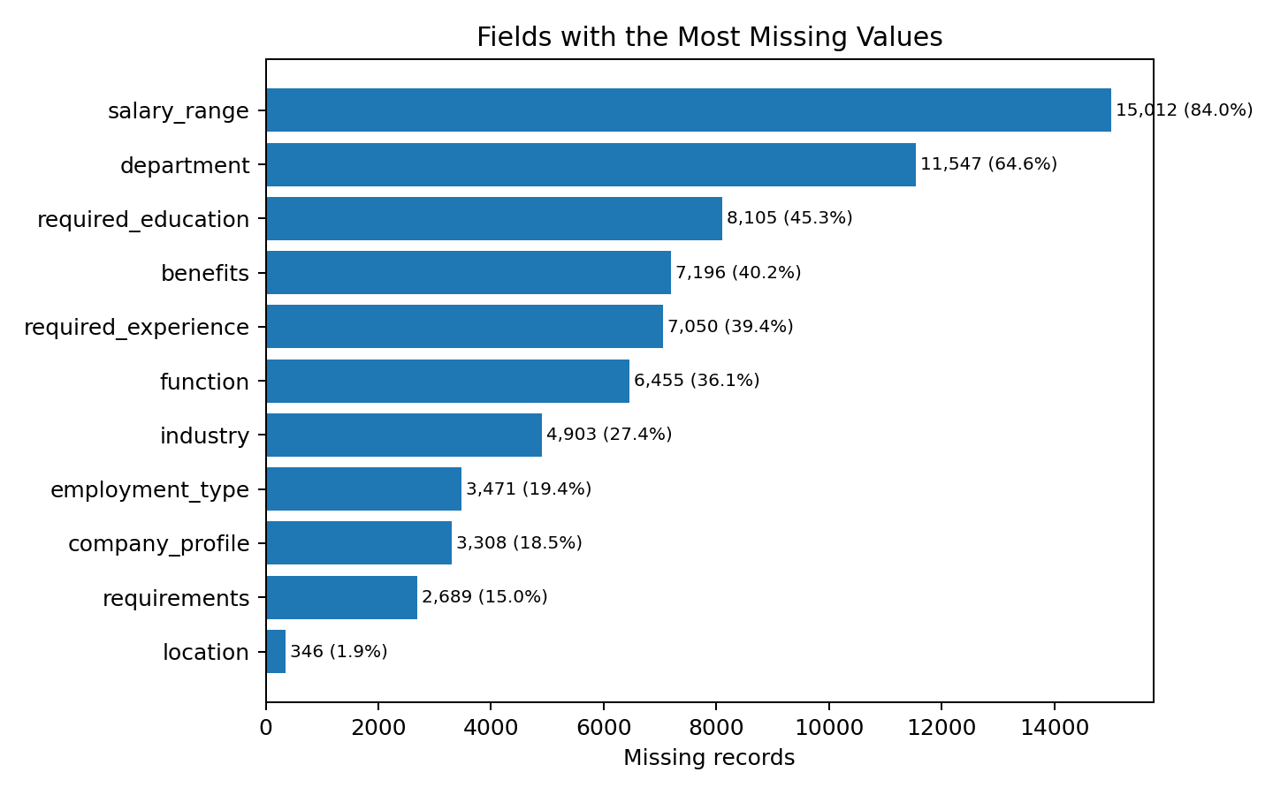
Figure 2. Fields with the largest number of missing values.

TEXT EXPLORATION
Selected phrases were counted when they appeared at least once in the combined title, company profile, description, requirements and benefits text. These counts are exploratory indicators only; a phrase by itself does not prove that a posting is fraudulent.
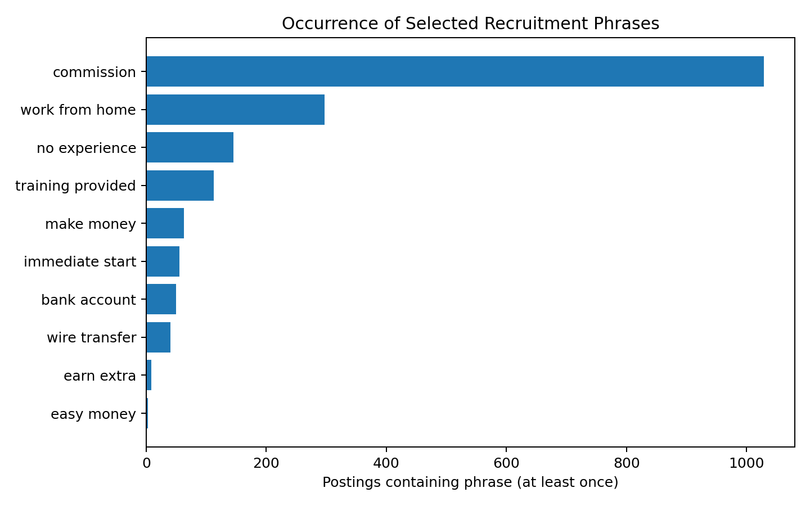
Figure 3. Frequency of selected recruitment phrases.

CLASSIFICATION EXPERIMENT
The text classifier uses TF-IDF features with unigrams and bigrams. The vectoriser is fitted on the training data only to avoid allowing information from the test set to influence feature construction. Logistic Regression is trained with class_weight=balanced, using an 80:20 stratified train-test split and random_state=42. The held-out test set contains 3,576 postings.
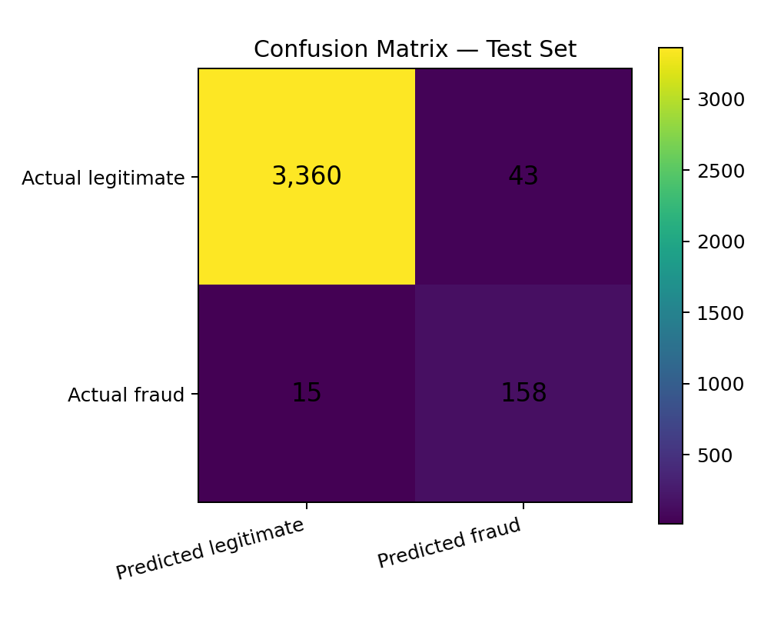
Figure 4. Confusion matrix on the held-out test set.

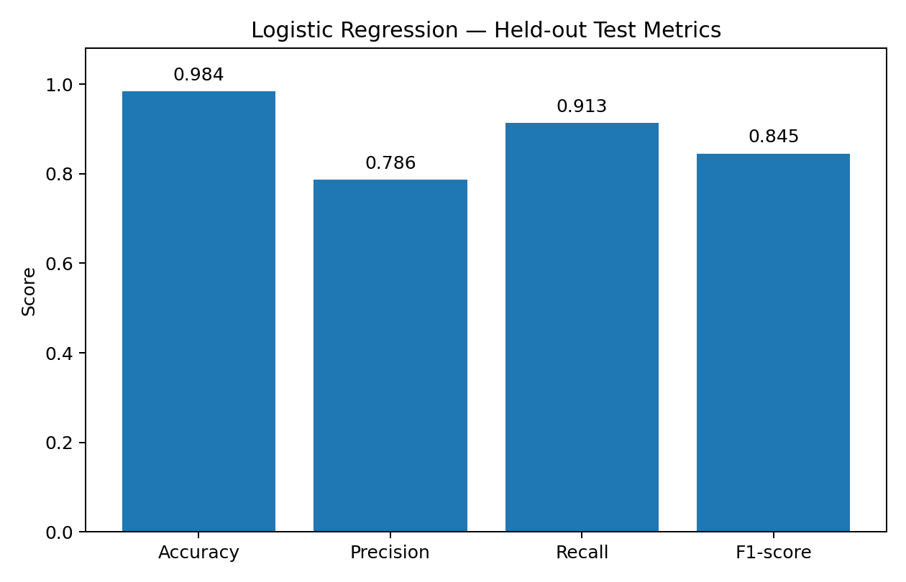
Figure 5. Accuracy, precision, recall and F1-score on the held-out test set.
On the held-out test set, the measured accuracy was 0.984, precision for the potentially fraudulent class was 0.786, recall was 0.913 and F1-score was 0.845. The confusion matrix contains 3,360 true negatives, 43 false positives, 15 false negatives and 158 true positives. These values describe this experiment and should not be interpreted as a guarantee of performance on new job advertisements.
These results are specific to this dataset and split. Because the classes are imbalanced, accuracy alone is not sufficient. Precision and recall should also be considered, and the model should be independently validated before any real recruitment decision.

CLUSTERING AND ASSOCIATION ANALYSIS
K-Means clustering was applied to a sample of 2,500 training postings represented by TF-IDF vectors. Truncated SVD reduced the high-dimensional text representation to two dimensions for the chart. The visualisation helps show broad groupings in the sampled text, but cluster numbers are mathematical group labels; they do not mean that a group is automatically safe or fraudulent.
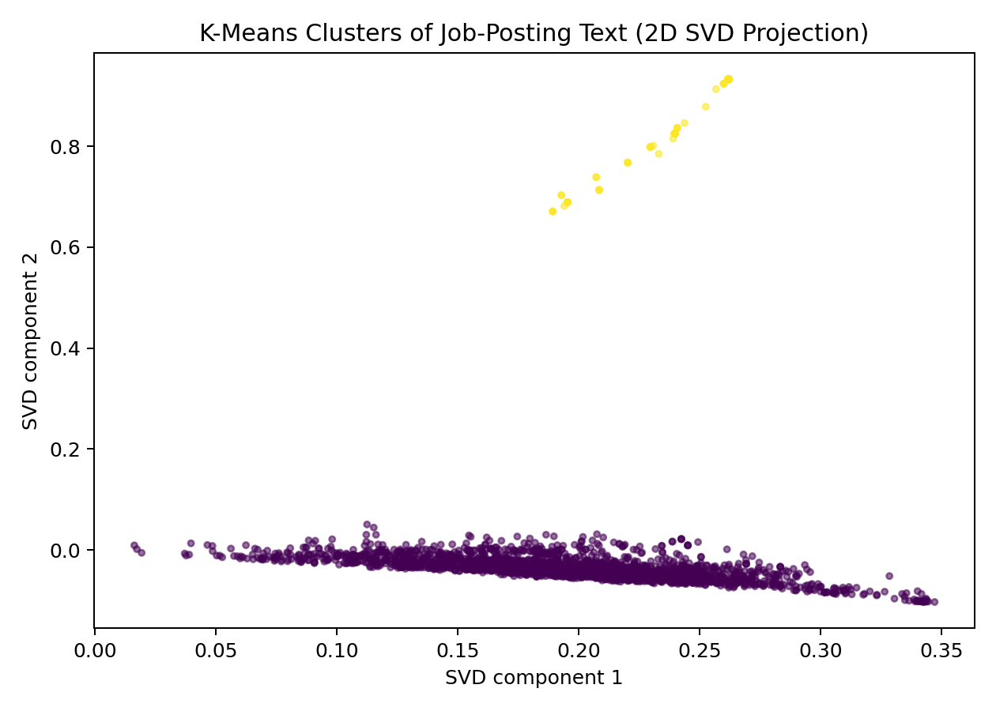
Figure 6. K-Means clusters shown in a two-dimensional SVD projection.

ASSOCIATION-RULE EXPLORATION
A frequent co-occurrence analysis was run over selected phrase indicators and available yes/no fields. Rules were retained using a minimum support of 0.2% and confidence of at least 25%. Lift compares a rule’s confidence with the baseline frequency of its consequent.
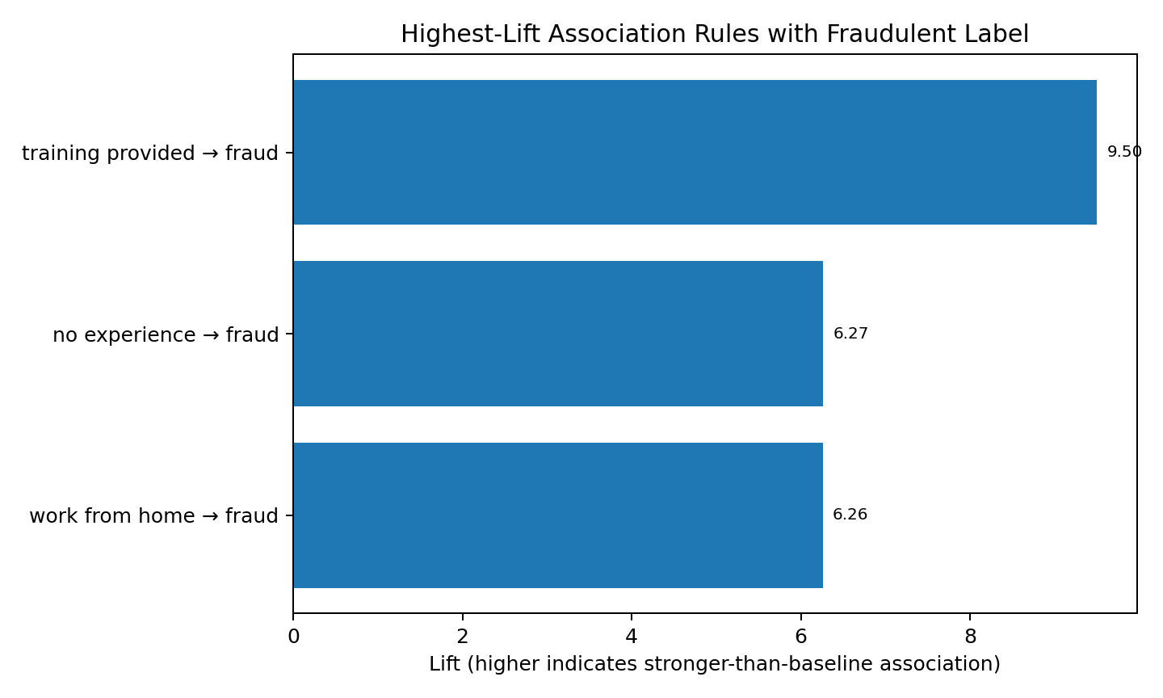
Figure 7. Highest-lift rules associated with the fraudulent label.
Rule: “training provided” → potentially fraudulent label; support=0.0029, confidence=0.460, lift=9.50.
Rule: “no experience” → potentially fraudulent label; support=0.0025, confidence=0.303, lift=6.27.
Rule: “work from home” → potentially fraudulent label; support=0.0050, confidence=0.303, lift=6.26.
Interpretation and limitation: these patterns indicate associations in this dataset, not causal relationships. The presence of “training provided”, “no experience” or “work from home” should never be treated as proof of fraud. A real user should verify the employer, website, contact details and any request for money or sensitive information.

REPRODUCIBILITY NOTE
The figures in this section were generated from the uploaded DataSet.csv during the analysis for this report. They are genuine outputs from the supplied dataset, not screenshots of a personal Google Colab session. The classification experiment used Python, pandas, scikit-learn and Matplotlib, with random_state=42 for the train-test split. The same data file and settings can be used to reproduce the analysis.

REFERENCES

References
1. Employment Scam Aegean Dataset (EMSCAD), publicly available dataset record and accompanying documentation. Verify the current source, licence, version and access date before use.
2. Pedregosa, F. et al. (2011). Scikit-learn: Machine Learning in Python. Journal of Machine Learning Research, 12, 2825–2830.
3. McKinney, W. (2010). Data Structures for Statistical Computing in Python. Proceedings of the 9th Python in Science Conference.
4. Han, J., Kamber, M. and Pei, J. Data Mining: Concepts and Techniques. Morgan Kaufmann.
5. Manning, C. D., Raghavan, P. and Schütze, H. Introduction to Information Retrieval. Cambridge University Press.
6. Official documentation: pandas, https://pandas.pydata.org/docs/
7. Official documentation: scikit-learn, https://scikit-learn.org/stable/
8. Official documentation: Google Colaboratory, https://colab.research.google.com/
9. Official documentation: mlxtend frequent patterns, https://rasbt.github.io/mlxtend/

